Seethalakshmi Achi College For Women

Pallathur

Affiliated By Alagappa University

Department of Commerce

III- B.com(CA)

**FINANCE AND ACCOUNTING WITH ZOHO BOOKS.**

**Travel Trax Tours**

**Team-9**

**Team members**

1. K. Senthtamil Veeraselvi. (Team Leader)

2. M. Sharmila.

3. S.sushmitha

4. S. Usharani.

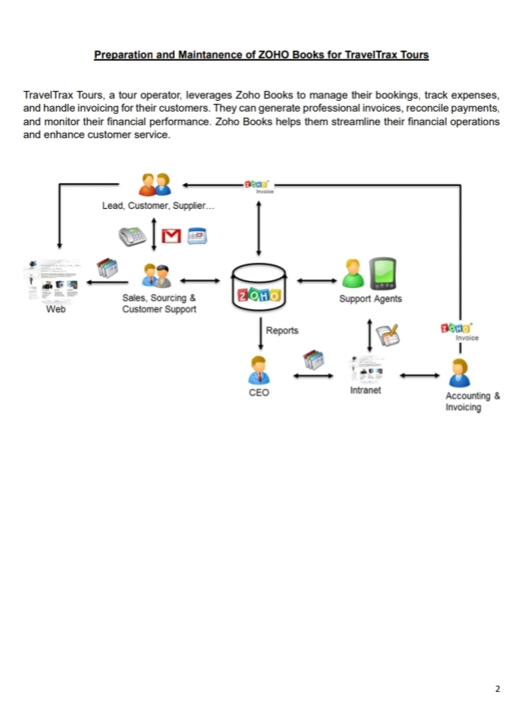

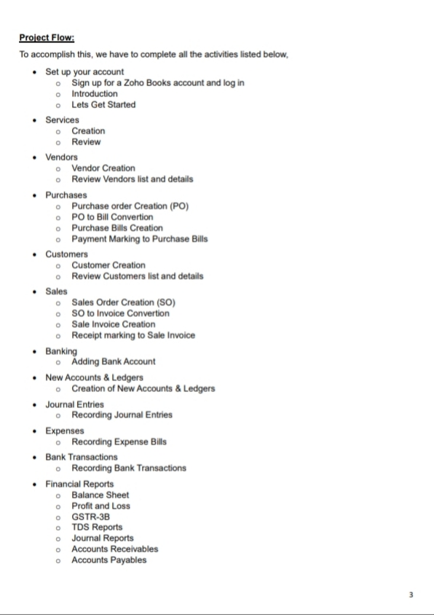

**Empathy Map:**

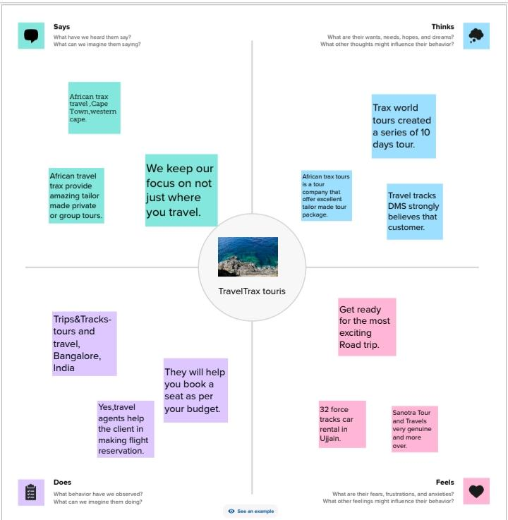

**Brainstorm and idea prioritisation:**

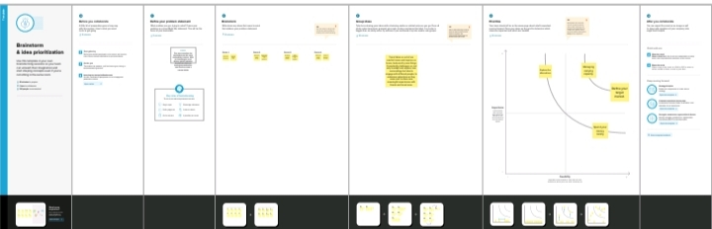

**Cash flow:**

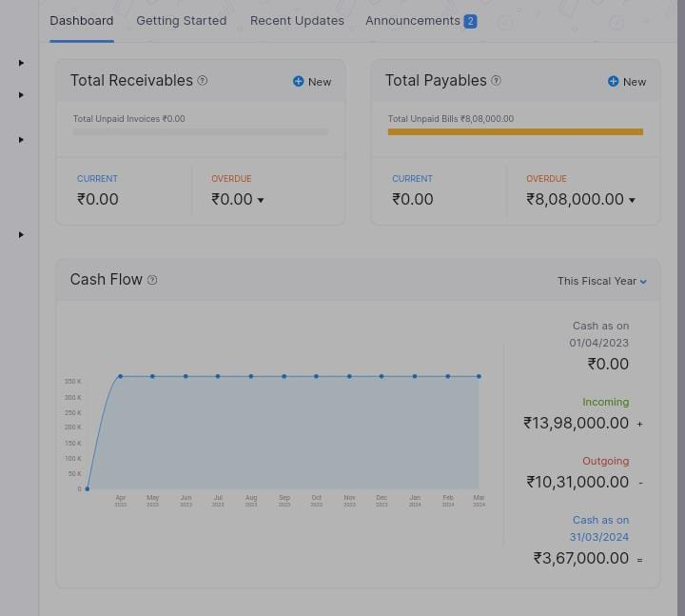

**Bar diagram:**

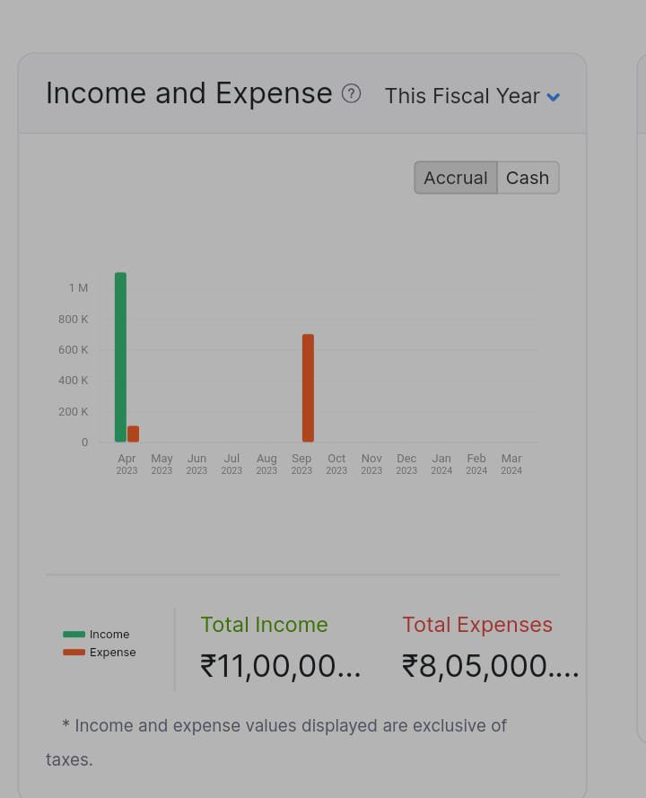

**Pie Chart:**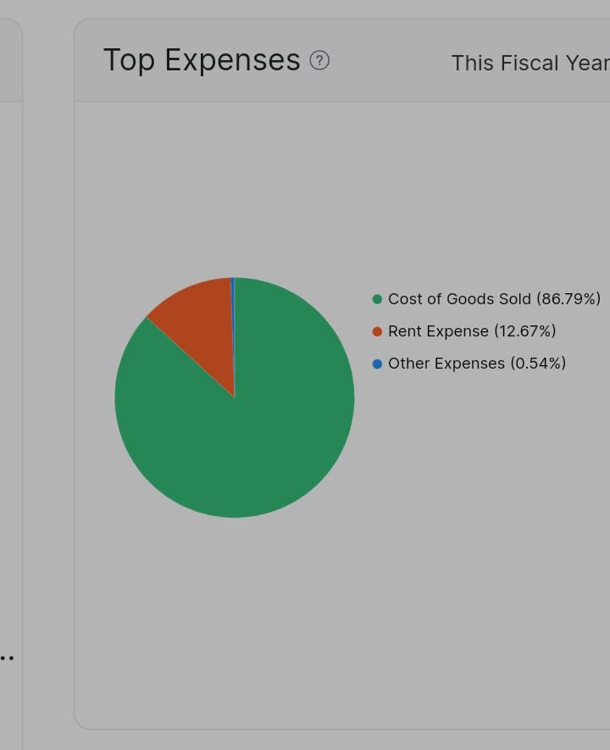

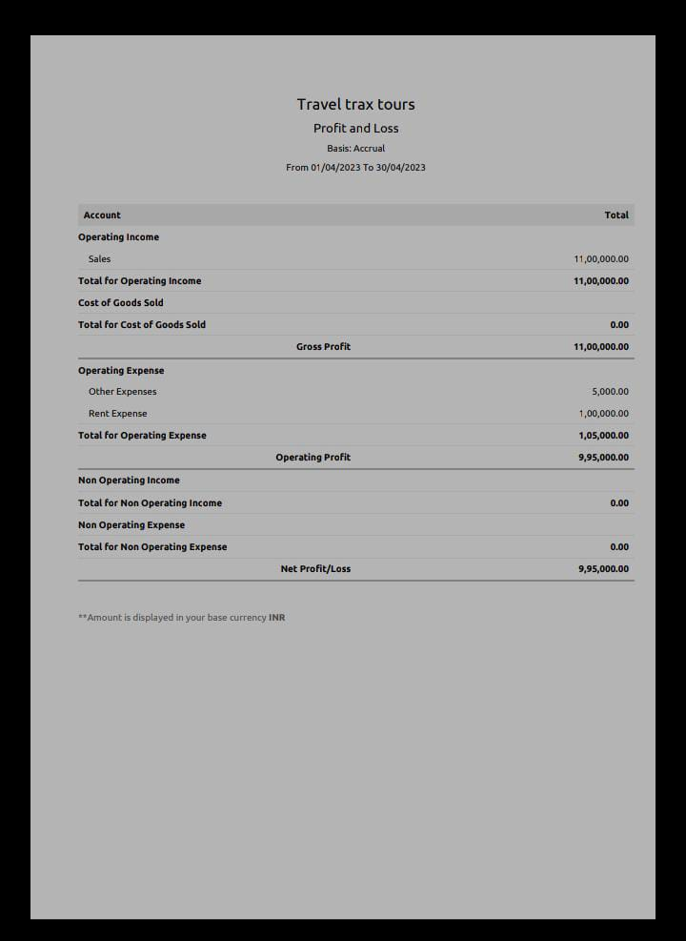

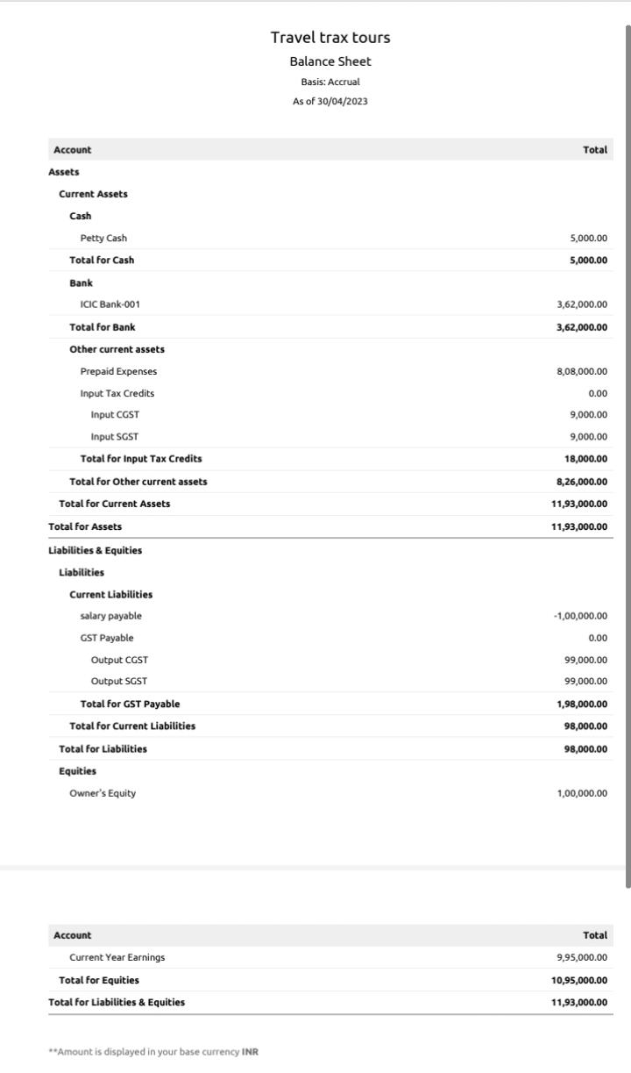**Result:**

**Advantage:**

* You will have an expert Tour Director to guide you.
* Local guides will ensure you never miss a things.
* Enjoy a perfect balance of touring and free time
* Make friends for life.
* Exceptional value for money.
* Curated experiences just for you.
* Travelling will improve your mental health.
* Travel helps you to reduce your stress and anixety.

**Disadvantage:**

* Limited freedom – You may not have much control over the itinerary, and you may be restricted to the set time for activities.
* Quality of accommodation.
* Limited flexibility.
* Limited options.
* Unpredictable weather.
* It is expensive compare to pre-packaged tour packages.
* Tourists ‘ Negligence of the environment.
* Exploitation of local culture.

**Conclusion:**

The transport system today plays a vital role in the development of India. It can be ranked among the most important sectors of the Indian economy. It is the most significant events for transporting goods and services from one place to another.

We can say that tourism is a very productive activity both for the tourist and the government. As they support each other simultaneously . Also,the government should consider improving the conditions of the country as more and more number of tourist visit their country.